**CAR RETAIL MANAGEMENT SYSTEM**

1. **Description of the Car Retail Management System**

* The details of Cars is stored into Cars table with below mentioned attributes.
* Each entity( Car Owners, Customer, Car Models, Cars) contain primary keys and unique keys.
* The entity Car Owners, Customers has binded with Cars, Car Models entities with foreign key
* There is one-to-one and one-to-many relationships available between Customer, Owners, Cars and models.
* All entities Cars, Customer, Car Owners,etc are normalized and reduced duplicacy of records.
* We have implemented indexing on each tables of Car Retail Management System tables for fast query execution.

1. **Car Retail Management System entities and their attributes**

* **Cars Entity:**
* car_id,
* car_customer_id,
* car_number,
* car_company,
* car_description
* **Car Models Entity:**
* car_model_id
* car_model_number
* car_model_year
* car_model_name
* car_model_type
* car_model_description
* **Car Owners Entity:**
* owner_id(liscence number)
* owner_name
* owner_mobile
* **Customer Entity:**
* cus_id(liscence number)
* cus_name
* cus_email
* cus_mobile
* cus_address

Entity-Relationship Model

**car_id**

**cm_year**

**CARS**

**CUSTOMER**

M

**cus_Lname**

**owner_mobile**

M

M

1

1

1

M

1

MANAGE

**CAR MODEL**

**cus_Fname**

**car_number**

**company**

**cus_mobile**

**car_desc**

**car_type**

**cus_id**

**HAS**

**CAR OWNER**

**cus_email**

**car_number**

**cm_name**

**cus_name**

**cm_id**

**car_desc**

**customer_id**

**owner_id**

**owner_name**

**own_Fname**

**own_Lname**

**cus_cus_id**

**add**

**car_company**

**Owner_id**

# ER TO RELATIONAL MODEL

**CAR**

|  |  |  |  |  |  |
| --- | --- | --- | --- | --- | --- |
| **car_id** | **car_desc** | **cus_id** | **car_number** | **company** | **owner_id** |

**CAR OWNER**

|  |  |
| --- | --- |
| **owner_id** | **own_name** |

**CUSTOMER**

|  |  |  |  |
| --- | --- | --- | --- |
| **Cus_id** | **Cus_email** | **Cus_add** | **Cus_name** |

**CAR MODEL**

|  |  |  |  |  |  |
| --- | --- | --- | --- | --- | --- |
| **Cm_id** | **Cm_name** | **Cm_year** | **Car_type** | **Car_desc** | **Car_number** |

**CAR OWNER MOBILE**

|  |  |
| --- | --- |
| **Owner_id** | **Owner_mobile** |

|  |  |
| --- | --- |
| **Cus_id** | **Cus_mobile** |

**CUSTOMER MOBILE**

**CREATION OF TABLES**

1. **CAR:**

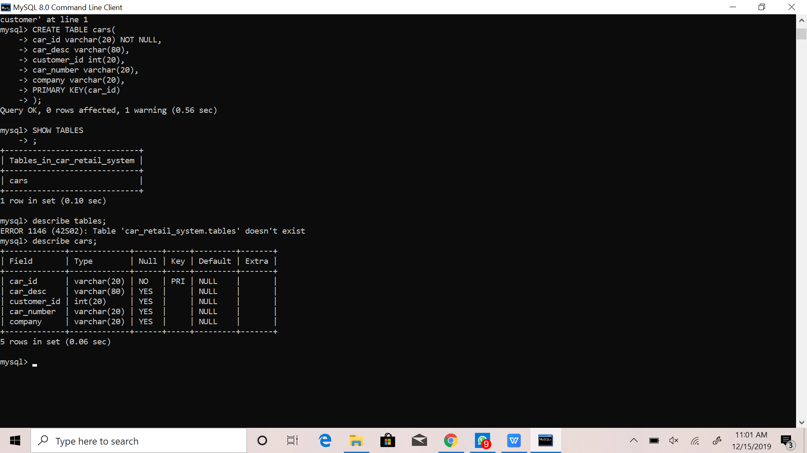

1. **CAR_OWNER:**

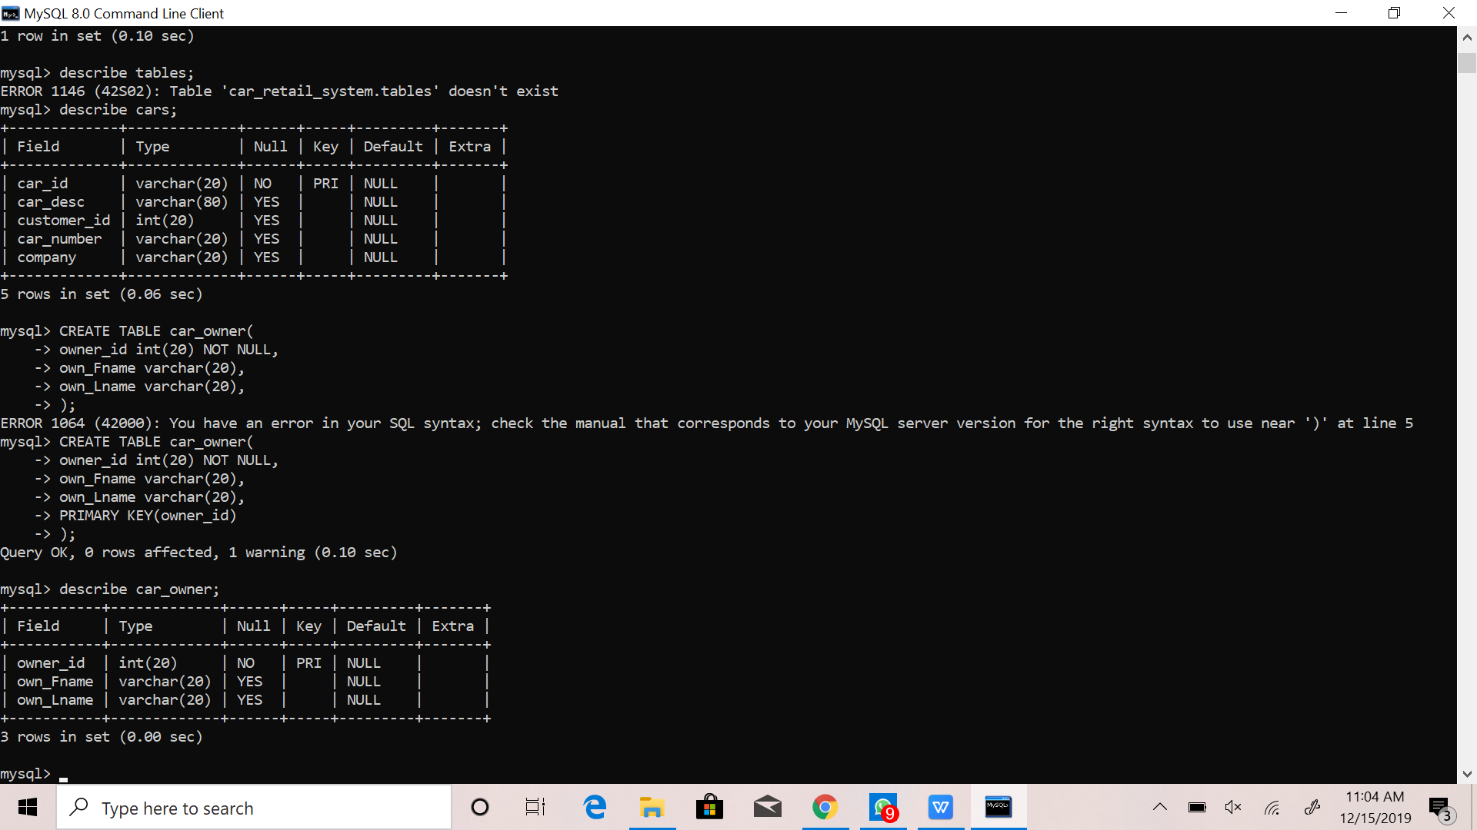

1. **OWNER_MOBILE:**

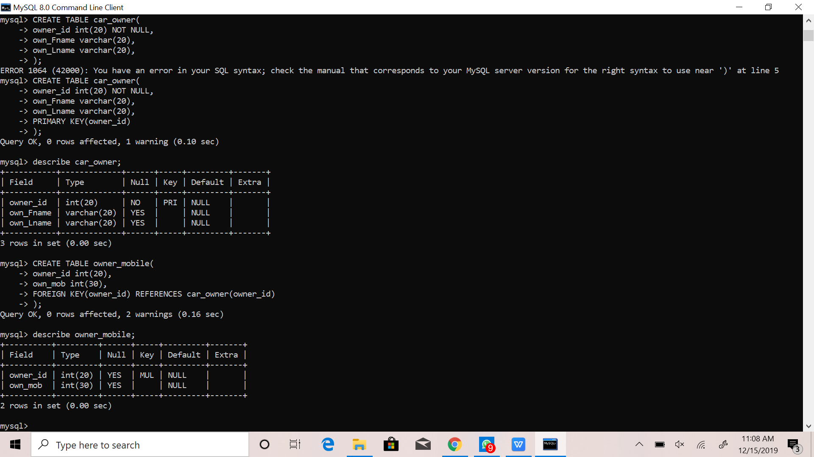

1. **CUSTOMER:**

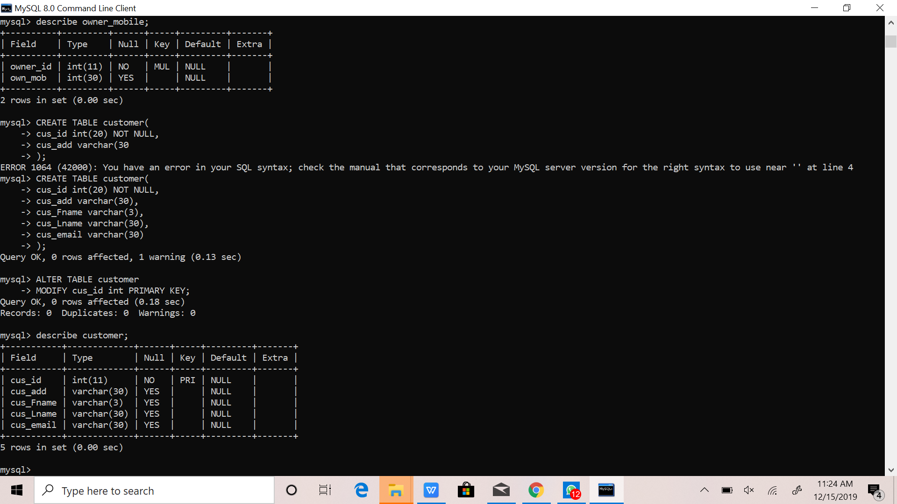

1. **CAR_MODEL:**

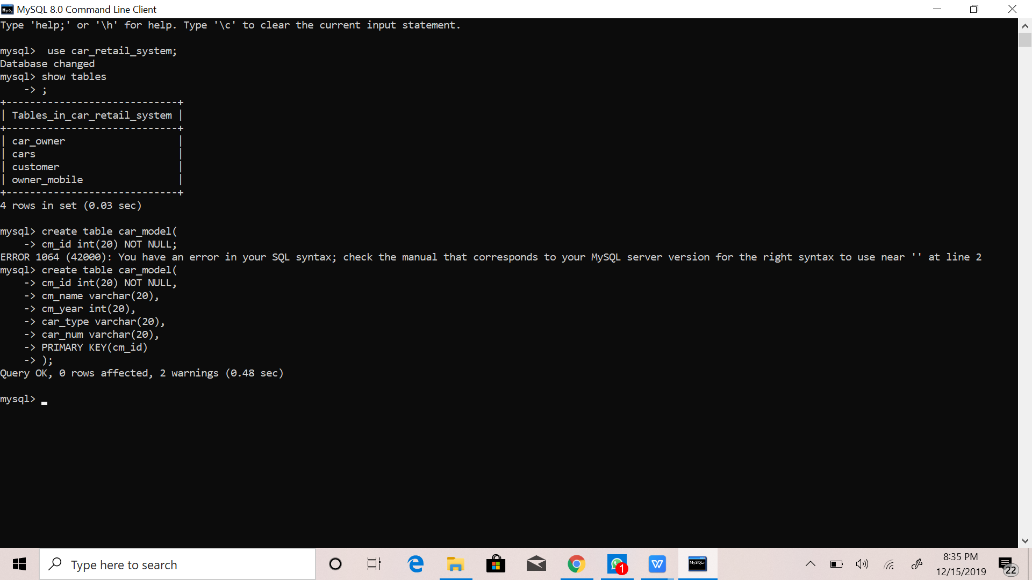

1. **CUSTOMER_MOBILE**

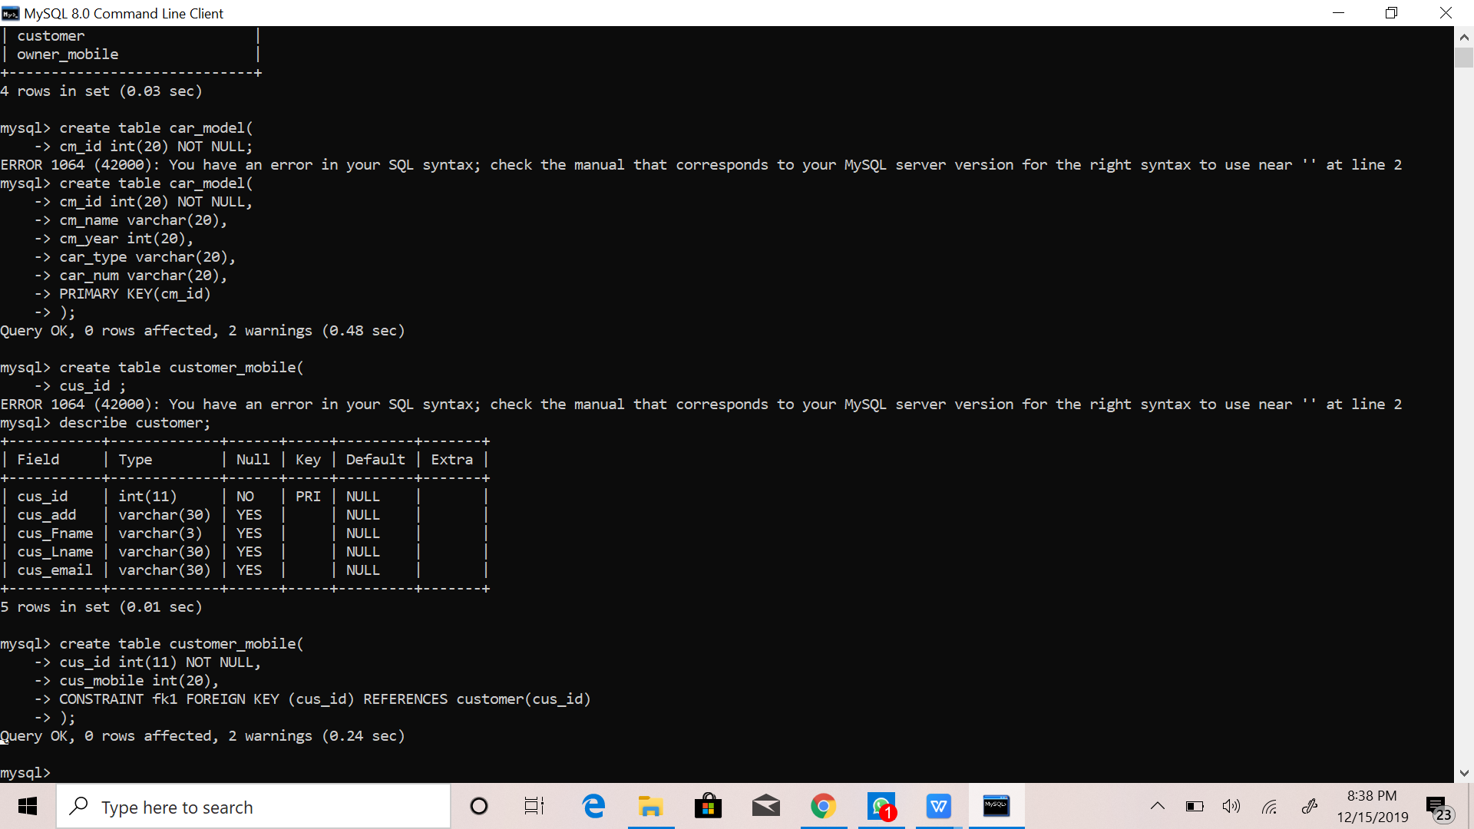

**INSERTION OF TABLES**

1. **CAR:**

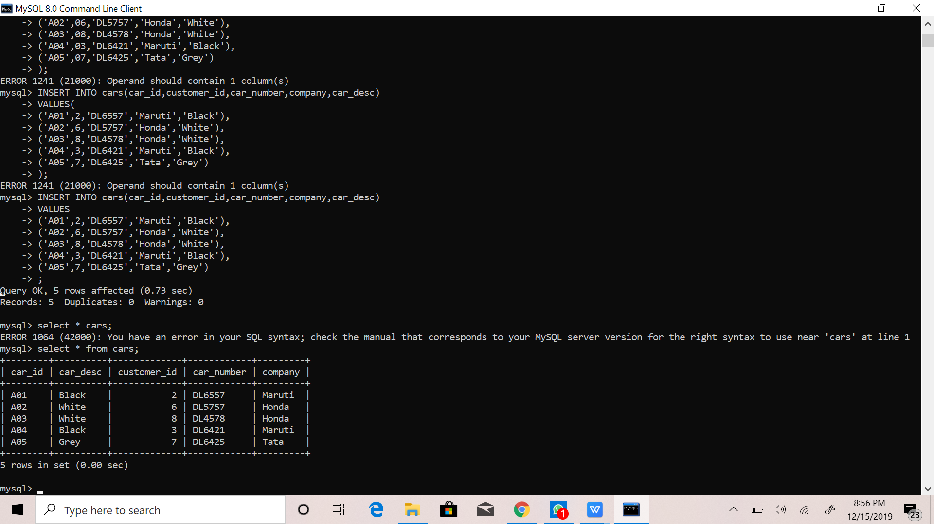



**2) CUSTOMER:**

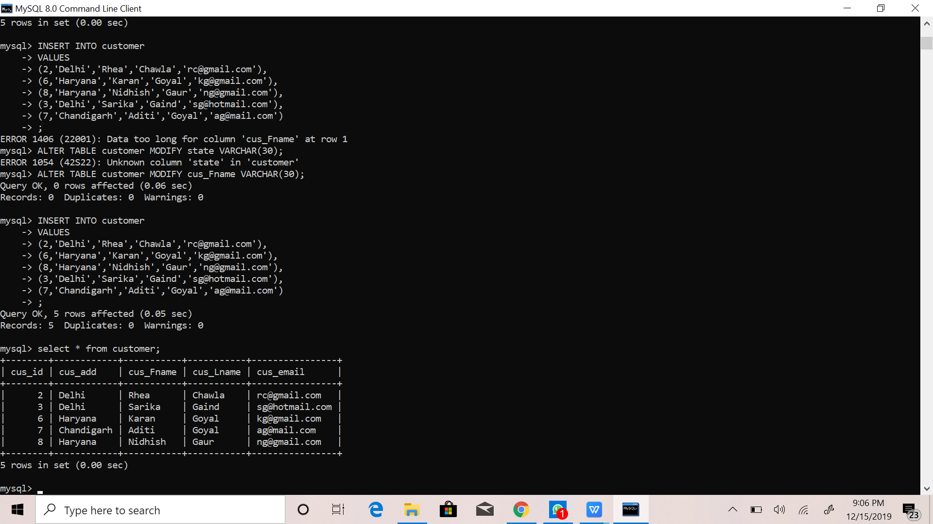



**3)CUSTOMER_MOBILE:**

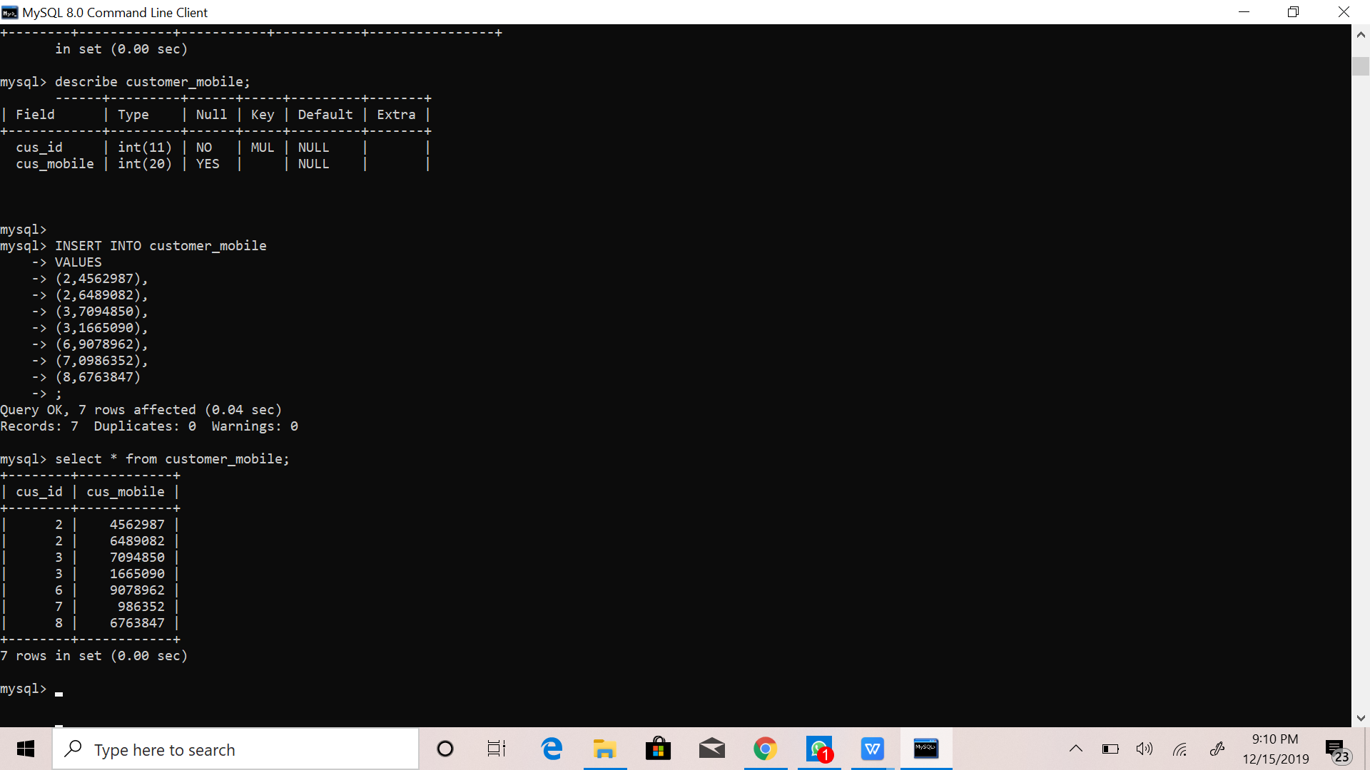



**4)CAR_OWNER:**

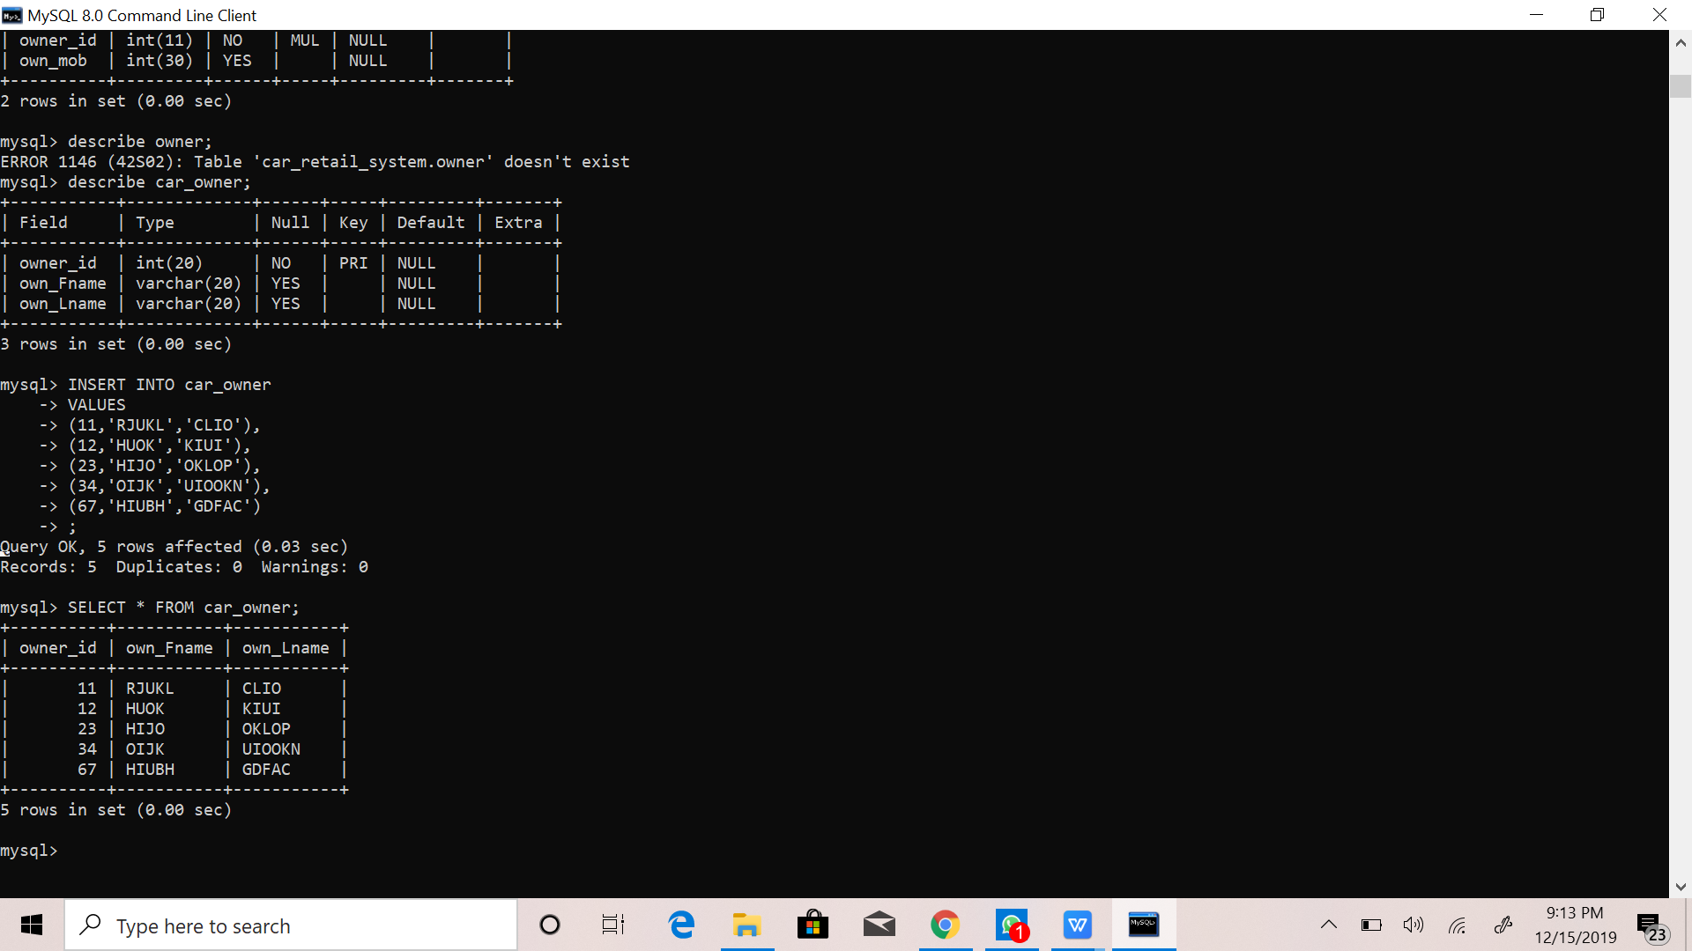



**5)OWNER_MOBILE:**

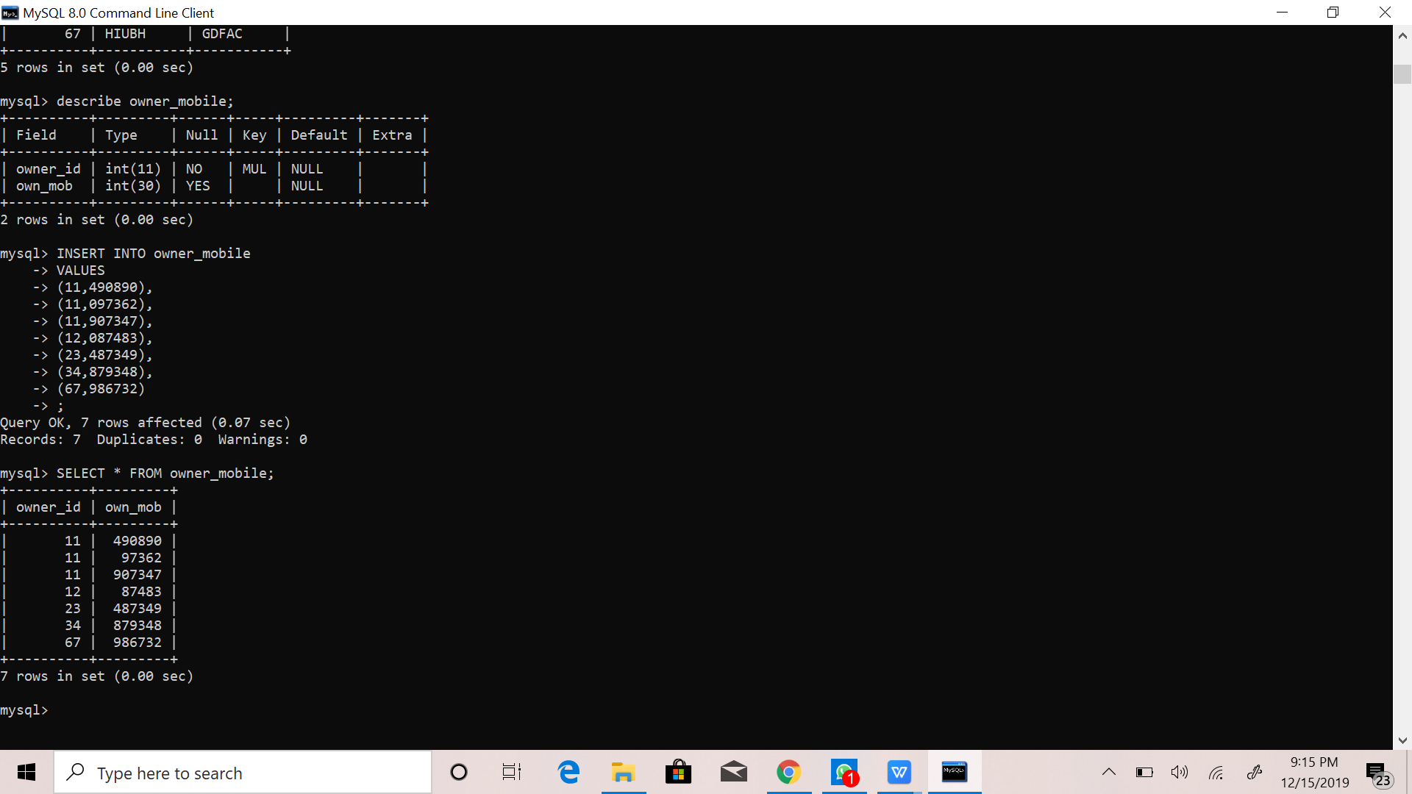

1. **CAR_MODEL:**

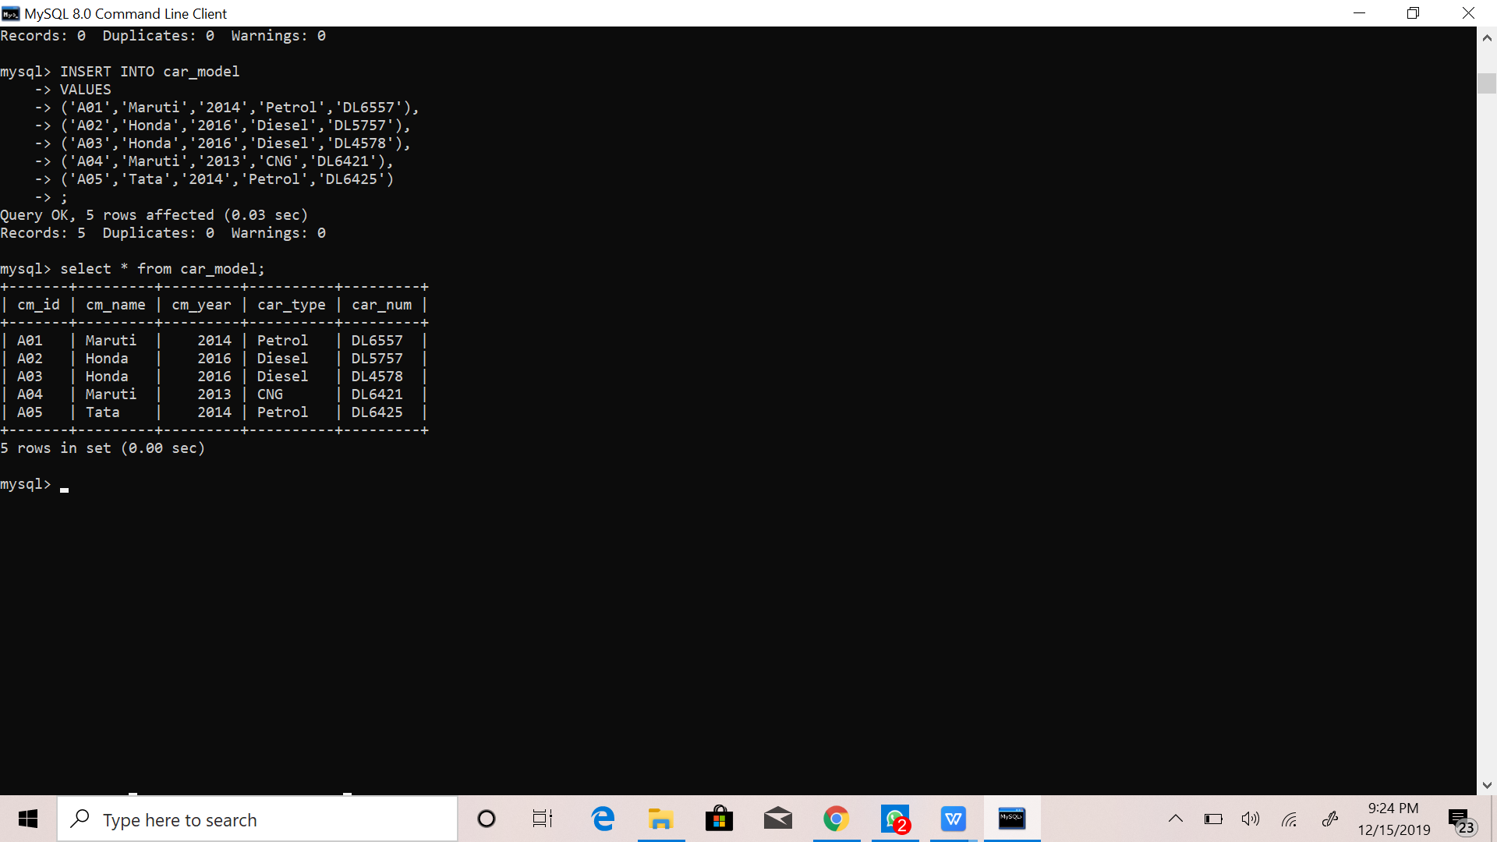

**MODIFICATION OF TABLES**